Client name Renewal Report – Month and year
(To check links below you may need to hold down the Control key when clicking or copy and paste the link into your browser)
Thank you for placing your business links on Linku2 Hibiscus Coast. This is a report of your stats over your past advertising term. You can click on the following links to view pages and links.
Please take a moment to check your current onsite pages and, as we hope you are continuing your advertising with us, advise any changes or updates and your current keywords and advise any others we should focus on in any new advertising term.
Your current advertising term ran from: Dates in bold
We look forward to continuing to support your business to Go Local, Grow Local ...

YOUR SITE PAGE
Get client linked site page(s) from the last report you sent them in WP Contact CRM

YOUR DIRECTORY CATEGORIES
Your above page is listed in the following categories –
List bullet pointed lists of categories (including the Local Business Quick Guide page) again from the last report you sent them in WP Contact CRM

YOUR HITS TO END MONTH AND YEAR (90 DAYS OR AS APPROPRIATE)
We understand the importance of being able to measure the value of your advertising dollar with us and report Google analytics and search console hits as follows –
- Directory page hits for your above on site page – Number of hits
- Your category page hits – Number of hits
- Your scrolling logo advert and link appears on the top level Education page and all subsequent section pages and also now all top level Babies and Kids page and subsequent pages with the following total hits – Number of hits
- Our Local Business Quick Guide page – Number of hits
- Direct hits to your website – Number of hits (take out this line if none or very low)
Google Search
- Our (category or query) page in search console – Number of impressions – Number of clicks (take out clicks reference if none)
- Our (category or query) page in search console – Number of impressions – Number of clicks (again take out clicks reference if none or very low)

KEYWORDS AND GOOGLE RANKINGS
Please note our site pages you are listed on have the following current Google rankings –
Bulleted list of keywords - linked and with their ranking No, eg
- Hibiscus Coast kindys – No 1
Remember when people are using Google they tend to have done all the research and are looking for that service. Either that or they are trying to find something that will fit their needs. You don’t have to spend time trying to convince them they have a problem or want to find a service, they’ve already understood this and want to find the solution, hopefully that's YOU through one of our impressions!
As a reminder how we work locally to get your links in front of your potential customers check out our Google Ranking article.

YOUR ONSITE ADVERTS

Put in images of any side and sponsor ads

STAT GRAPHS

Put in images of search or analytics graphs of particular relevance and quality – only 2-3 at most. Eg

Childcare page impressions and clicks

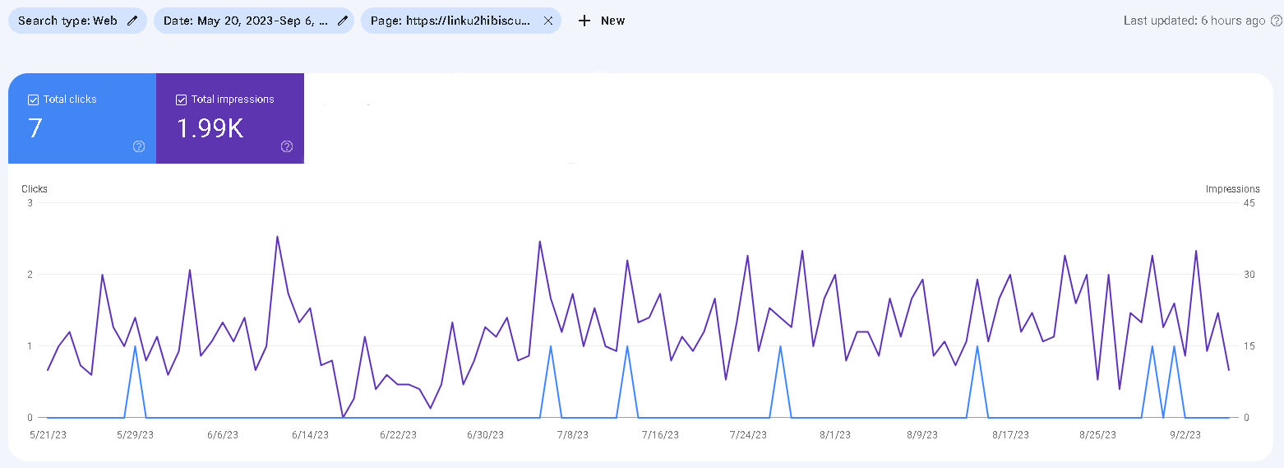

Same with any particular Linku2 stats, eg

Linku2 Hibiscus Coast Users and Page Views Google Report for August 2023

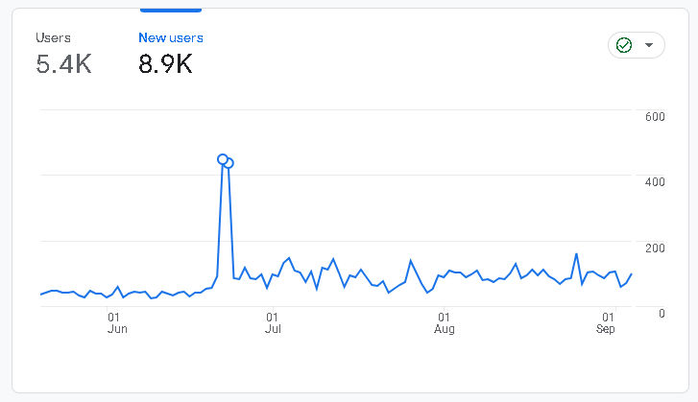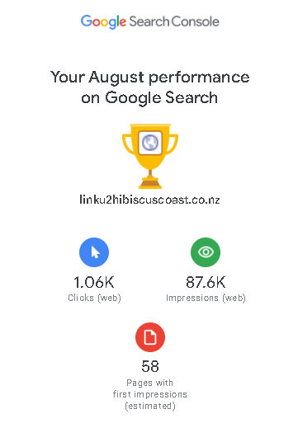

GENERAL LINKU2 HIBISCUS COAST SITE STATS
- Over the time period since your current advertising term started our site has had Number of site visitors with Number of these being regular return visitors.
- These visitors have viewed Number of site pages with the average user viewing Number of pages each session
- Of the above Number of users Number came from organic searching showing the importance of good Google rankings for keywords

(above or any other particularly good stats you’d like to quote)

If you would like any changes to your current advertising, wording, images, etc, or if you would like us to optimise for other specific keywords, please let us know.

We thank you for putting your trust in Linku2 Hibiscus Coast and look forward to continuing to support your business to Go Local, Grow Local …

